I have checked the Teams Phone System back and dial plan seems ok and Dial Plan translating 1300 numbers ok:

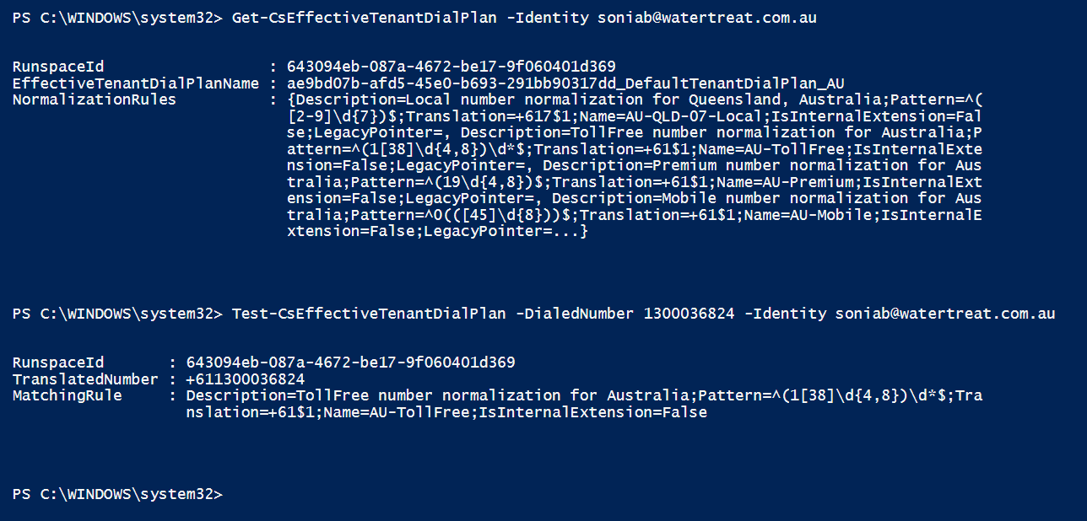

I can only see two attempts in Sonia’s call history to call a 1300 number over the last 3 weeks, the latest one failed but previous lasted 8 secs. Both seem to be the same 1300 number.





I have asked Sonia to call Entag’s 1300 number to better confirm if we have a general problem or not.